Machine learning potential for predicting the properties and simulating the degradation behavior in polymeric materials
Anas Karuth and Bakhtiyor Rasulev
North Dakota State University
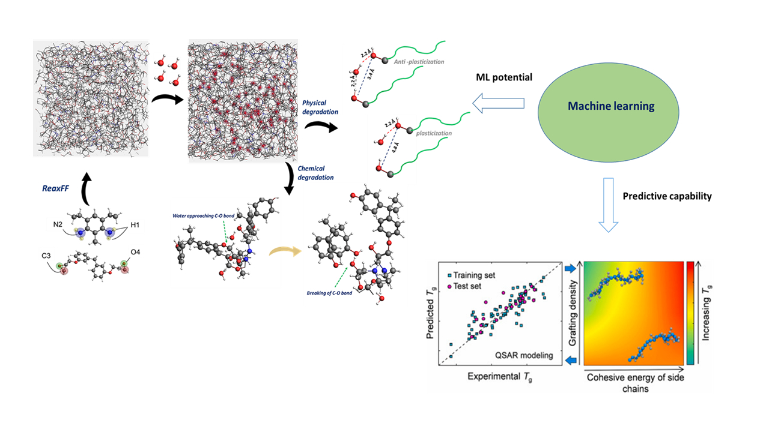
Data-driven machine learning techniques are gaining popularity in chemical science due to their ability to predict the properties of chemical compounds with unprecedented efficiency and high accuracy. We utilize machine learning methods to build a quantitative relationship between the chemical and functional descriptors and properties of the polymeric systems, including glass transition temperature. To develop the model, we train a few hundred polymeric structures using ML methods based on genetic algorithms to learn from patterns or structures in the data and to build a structure and property relationship model. In this study, the ML methods are coupled with coarse-grain molecular dynamics (MD) to further delineate the mechanistic interpretation and systematic dependence of these ML-identified influential structural features in the polymeric system. This synergistic modeling framework provides a valuable insight into the roles of key molecular features influencing the physicochemical properties of polymers, paving the way to establishing a materials-by-design framework for polymeric materials via molecular engineering. The machine learning (ML) interatomic potential formed by training the quantum-mechanical data is used in the development of the reactive force field (ReaxFF). The ReaxFF is a perfect force field for MD simulations or reactive systems which has lower computational expense and makes it possible to reach a simulation scale not tractable for quantum mechanics. The inclusion of connectivity dependent term in the quantum-mechanically trained empirical force field ReaxFF, enable us to study the reactive events in the chemical systems. We utilized the ReaxFF framework to study the physical and chemical degradation in epoxy thermosets due to moisture ingress. We used all-atomistic MD simulations to model the reversible and irreversible hygrothermal degradation process in water-sensitive epoxy thermosets

